Contact:
B.Sc. Vanessa Frekers
v.frekers@sigmasoft.de
+49-241-89495-0
Kackertstr. 11
D-52072 – Aachen

Press Release
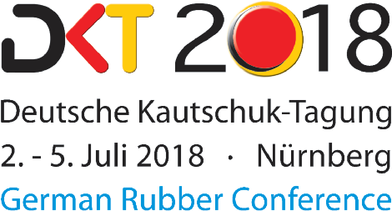

Hall 12, Stand 419

Rubber injection molding
Fully Transparent Elastomer Molds through Virtual Molding

The heating concept has significant influence on part quality and the efficiency of the process for injection molded elastomer applications. To produce prime quality parts and design an energy efficient mold, SIGMASOFT® Virtual Molding is already used in early development stages of the mold. Thus, the heating concept, mold and process are optimally designed and made transparent for the molder.

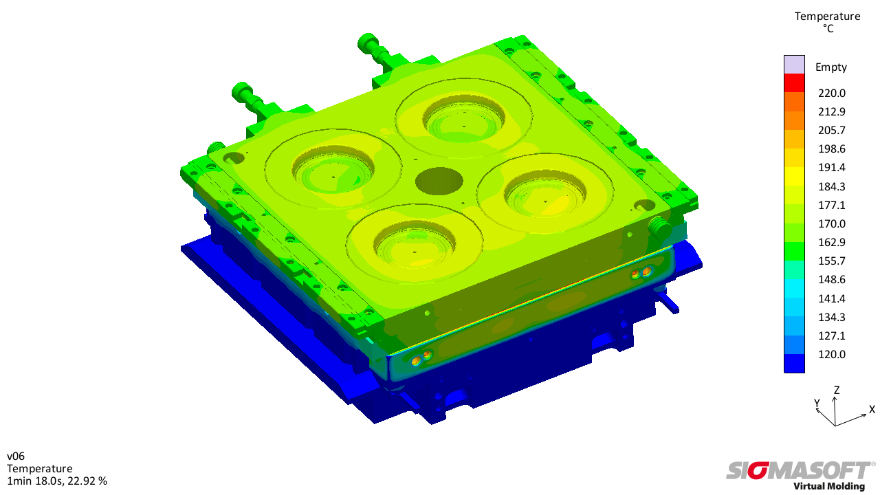
Figure 1 – To analyze the thermal mold layout, all components of the mold are taken into account and virtual parts are produced over several cycles to realistically reproduce the conditions of production
Fully Transparent Elastomer Molds through Virtual Molding

Aachen, July 2nd, 2018 – The mold is the main influencing factor for robust as well as energy and cost efficient rubber injection molding processes. Not only is it a precondition for good and constant part quality, it also has major influence on the amount of scrap and the energy efficiency of the whole process. For these reasons, simulation is used more and more frequently to optimize molds in an early stage.
With the help of the SIGMASOFT® Virtual Molding technology, users receive an insight into the mold performance during the full process before it is even built. The thermal behavior of all mold components during heating up and starting up the mold, as well as during production, are calculated and displayed on the computer. For this purpose, all geometries, mold alloys and planned process settings are considered by the software and the full injection process is calculated over several cycles. Thus, the computer becomes a virtual injection molding machine, which not only allows the set-up of the process without wasting resources, but also helps to analyze the mold in every detail. The mold becomes fully transparent and the thermal mold layout and its influence on part quality can be evaluated early in the development phase.
Important questions concerning the heating concept like the necessary number, layout, size and power of the heating cartridges are answered. Possible control circuits are tested preliminary and cartridges can be bundled in the optimum configuration. The influence of the planned concept on part filling and curing reaction is also evaluated virtually. Feasibility of possible counter measures is directly tested on the computer without wasting material. SIGMASOFT® Virtual Molding helps the users to design optimal molds and processes early while saving resources. Furthermore, mold iterations and trial-and-error on the machine are significantly reduced.

SIGMA (www.sigmasoft.de) is sister company to MAGMA (www.magmasoft.de), the world market leader in casting process simulation technology based in Aachen, Germany. Our SIGMASOFT® Virtual Molding technology optimizes the manufacturing process for injection molded plastic components. SIGMASOFT® Virtual Molding combines the 3D geometry of the parts and runners with the complete mold assembly and temperature control system and incorporates the actual production process to develop a turnkey injection mold with an optimized process.

At SIGMA and MAGMA, our goal is to help our customers achieve required part quality during the first trial. The two product lines – injection molded polymers and metal castings – share the same 3D simulation technologies focused on the simultaneous optimization of design and process. SIGMASOFT® Virtual Molding thus includes a variety of process-specific models and 3D simulation methods developed, validated and constantly improved for over 25 years. A process-driven simulation tool, SIGMASOFT® Virtual Molding provides a tremendous benefit to production facilities. Imagine your business when every mold you build produces required quality the first time, every time. That is our goal. This technology cannot be compared to any other simulation approach employed in plastics injection molding.

New product success requires a different communication between designs, materials, and processes that design simulation is not meant for. SIGMASOFT® Virtual Molding provides this communication. SIGMA support engineers, with 450 years of combined technical education and practical experience, can support your engineering goals with applications specific solutions. SIGMA offers direct sales, engineering, training, implementation, and support, by plastics engineers worldwide.

This press information is available to download as pdf and doc format under the following link: www.sigmasoft.de/press

