Contact:
B.Sc. Vanessa Frekers
v.frekers@sigmasoft.de
+49-241-89495-0
Kackertstr. 11
D-52072 – Aachen

Press Release
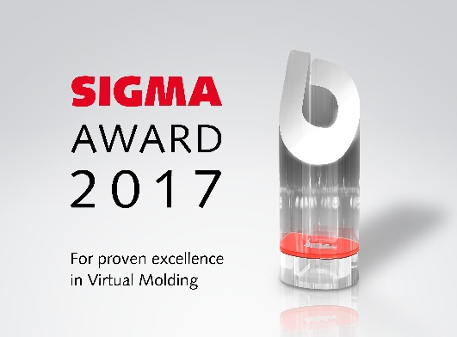
SIGMA Award
Günther Heisskanaltechnik and Speedturtle rewarded in 2017

SIGMA Engineering presents SIGMA Award for the first time

During the third SIGMASOFT® International User Meeting at the beginning of November SIGMA Engineering presented the SIGMA Award for the first time. Rewarded projects show a consistent use of SIGMASOFT® Virtual Molding to reduce costs or necessary resources significantly. The first winners are GÜNTHER Heisskanaltechnik and Speedturtle.

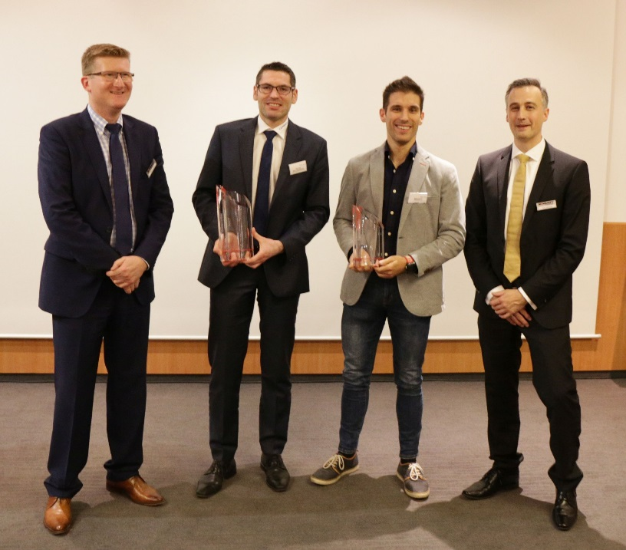
Figure 1 – Winners of the SIGMA Award 2017 with the management of SIGMA (left to right): Thomas Klein, General Manager at SIGMA, Dipl. Ing. Marco Kwiatkowski (Günther Heisskanaltechnik), Marco Ruivo (Speedturtle) and Dipl. Ing. Timo Gebauer, CTO SIGMA
Günther Heisskanaltechnik and Speedturtle rewarded in 2017

Aachen, December 8th 2017 – For years SIGMA Engineering GmbH, Aachen, Germany, finds projects at their customers, in which the full potential of modern simulation approaches has been used. To honor the customers, who optimize their projects with a consistent use of SIGMASOFT® Virtual Molding, in 2017 SIGMA presented the SIGMA Award for the first time. It is granted to customers, who in realizing new projects shorten the SoP and significantly reduce costs and resources by the comprehensive use of SIGMASOFT®. The award ceremony was part of the SIGMASOFT® International User Meeting.
The first SIGMA Award is granted to the company GÜNTHER Heisskanaltechnik GmbH from Frankenberg, Germany. Dipl. Ing. Marco Kwiatkowski, Head of Production and Development Thick Film, explained how hot runners are optimized at GÜNTHER with the help of SIGMASOFT®. “The thermally and rheologically calculated hot runners can be mounted on the mold immediately at our customers and allow a continuous and indulgent processing of the polymer due to the uniform temperature distribution from the connection nozzle over the manifold and hot runner nozzle up to the cavity. Because of the thermal evaluation of our manifold systems we can eliminate unbalanced filling of cavities due to hot spots or cold areas”, explains Kwiatkowski. “We are delighted at winning the first SIGMA Award.”
Because of the many projects worthy of recognition, SIGMA decided to already grant a second award during the first ceremony. The mold maker Speedturtle from Batalha, Portugal, only started working with SIGMASOFT® in the middle of 2016. Since then, General Manager Marco Ruivo and his team could already optimize a number of molds with the help of simulation. “With using SIGMASOFT® we take more time for the first steps during designing a new mold, but in the end we can deliver to our customers much faster, as we have less iterations for each mold. The honor of the SIGMA Award shows us we are definitely following the right approach”, explains Ruivo.
“Our customers use simulation on a very high level”, explains Thomas Klein, General Manager of SIGMA, “With the SIGMA Award we want to acknowledge how they solve complex and challenging questions with the help of our software.”

SIGMA (www.sigmasoft.de) is a sister company to MAGMA (www.magmasoft.de), the world market leader in casting process simulation technology based in Aachen, Germany. Our SIGMASOFT® Virtual Molding technology optimizes the manufacturing process for injection molded plastic components. SIGMASOFT® Virtual Molding combines the 3D geometry of the parts and runners with the complete mold assembly and temperature control system and incorporates the actual production process to develop a turnkey injection mold with an optimized process.

At SIGMA and MAGMA, our goal is to help our customers achieve required part quality during the first trial. The two product lines – injection molded polymers and metal castings – share the same 3D simulation technologies focused on the simultaneous optimization of design and process. SIGMASOFT® Virtual Molding thus includes a variety of process-specific models and 3D simulation methods developed, validated and constantly improved for over 25 years. A process-driven simulation tool, SIGMASOFT® Virtual Molding provides a tremendous benefit to production facilities. Imagine your business when every mold you build produces required quality the first time, every time. That is our goal. This technology cannot be compared to any other simulation approach employed in plastics injection molding.

New product success requires a different communication between designs, materials, and processes that design simulation is not meant for. SIGMASOFT® Virtual Molding provides this communication. SIGMA support engineers, with 450 years of combined technical education and practical experience, can support your engineering goals with applications specific solutions. SIGMA offers direct sales, engineering, training, implementation, and support, by plastics engineers worldwide.

This press information is available to download as pdf and doc format under the following link: www.sigmasoft.de/press

