Contact:

B.Sc. Vanessa Frekers
v.frekers@sigmasoft.de
+49-241-89495-0
Kackertstr. 11
D-52072 – Aachen

Press Release
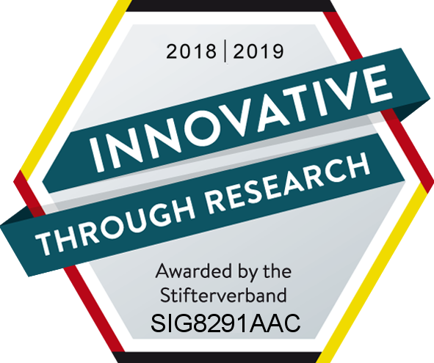

SIGMA Certified with Quality Seal “Innovative through Research” anew

SIGMA Engineering GmbH was again awarded with the quality seal “Innovative through Research” by the “Stifterverband für die Deutsche Wirtschaft”. The seal shows the Stifterverband’s appreciation of researching companies in Germany.

Aachen, September 27th 2018 – In September 2018 SIGMA Engineering GmbH, Aachen, Germany, again received the quality seal “Innovative through Research”. In continuity of the past years, SIGMA was certified as company with a strong commitment to research and development by the “Stifterverband für die Deutsche Wirtschaft”. Since the first awarding in 2014, SIGMA belongs to the circle of awarded companies.
To continuously improve the SIGMASOFT® Virtual Molding Technology, SIGMA is regularly engaged in research projects and works in close cooperation with universities as well as research institutes. “As technology driven company the continuous development of our software is very important to us. Only with this approach we can provide a product to our customers, which supports them in their daily challenges. For this reason we fully invest our revenue into development to encourage innovations”, explains Timo Gebauer, SIGMA’s CTO.
But SIGMA not only works in close cooperation with universities and research facilities, it is also actively involved in a number of associations. “The various meetings of the associations are an important opportunity to discuss up-to-date development topics with the industry as well as research facilities. Here we can learn more about the current situation of the plastic processing industry and which current challenges it is facing. And by doing so, we learn in which fields our development is of special importance to further improve plastics technology”, adds SIGMA General Manager, Thomas Klein.
The quality seal “Innovative through Research” appreciates SIGMA’s commitment in these areas. “The needs of our customers provide our company with the motivation to remain active in research and to further improve our product. We continuously invest in the development of our technology to promote innovations in injection molding”, concludes Mr. Klein.

SIGMA (www.sigmasoft.de) is sister company to MAGMA (www.magmasoft.de), the world market leader in casting process simulation technology based in Aachen, Germany. Our SIGMASOFT® Virtual Molding technology optimizes the manufacturing process for injection molded plastic components. SIGMASOFT® Virtual Molding combines the 3D geometry of the parts and runners with the complete mold assembly and temperature control system and incorporates the actual production process to develop a turnkey injection mold with an optimized process.

At SIGMA and MAGMA, our goal is to help our customers achieve required part quality during the first trial. The two product lines – injection molded polymers and metal castings – share the same 3D simulation technologies focused on the simultaneous optimization of design and process. SIGMASOFT® Virtual Molding thus includes a variety of process-specific models and 3D simulation methods developed, validated and constantly improved for over 25 years. A process-driven simulation tool, SIGMASOFT® Virtual Molding provides a tremendous benefit to production facilities. Imagine your business when every mold you build produces required quality the first time, every time. That is our goal. This technology cannot be compared to any other simulation approach employed in plastics injection molding.

New product success requires a different communication between designs, materials, and processes that design simulation is not meant for. SIGMASOFT® Virtual Molding provides this communication. SIGMA support engineers, with 450 years of combined technical education and practical experience, can support your engineering goals with applications specific solutions. SIGMA offers direct sales, engineering, training, implementation, and support, by plastics engineers worldwide.

This press information is available to download as pdf and doc format under the following link: https://www.sigmasoft.de/en/press/

