Contact:

B.Sc. Vanessa Frekers
v.frekers@sigmasoft.de
+49-241-89495-0
Kackertstr. 11
D-52072 – Aachen

Press Release

Thermoplastic Injection Molding
Virtual Process Design Optimizes Mechanical Properties of Parts

The fiber orientation of a part crucially influences its mechanical properties as well as its shrinkage and warpage behavior. Additionally, those will also be influenced by the process itself. Via the virtual process design in SIGMASOFT®, different approaches are compared with each other efficiently. Thus, the user gains a sound basis for safe decisions regarding the project and for finding the optimal design fitting the application’s requirements.

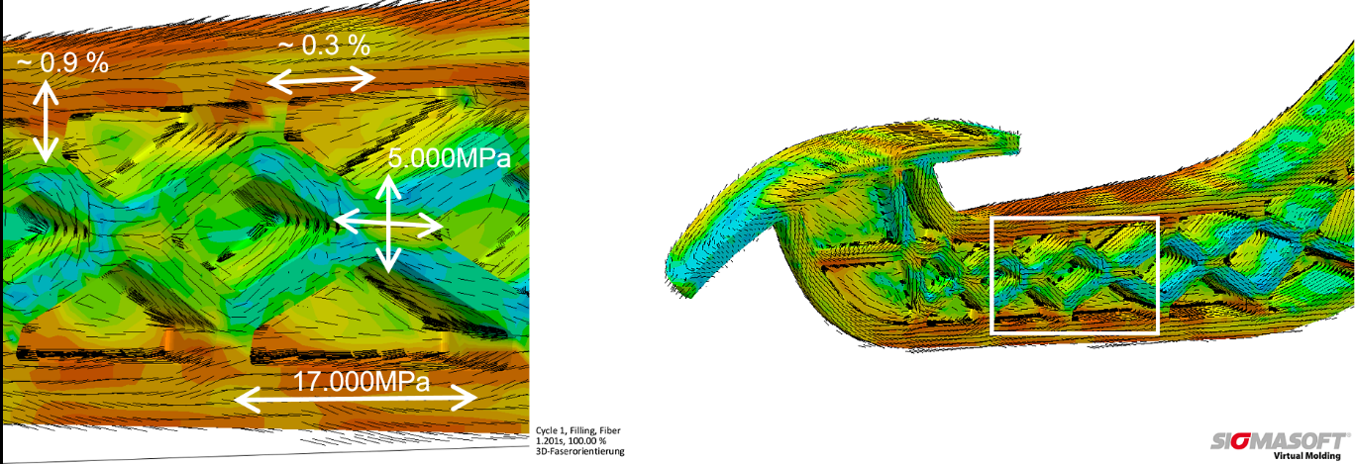
Figure 1 – Fiber orientation inside the part (right) and the resulting mechanical properties (left)
Virtual Process Design Optimizes Mechanical Properties of Parts

Aachen, October 16th, 2018 – The mechanical properties as well as the shrinkage and warpage behavior of fiber-reinforced parts are strongly depending on its fiber orientation (Figure 1). If the lightweight construction properties of these plastics shall be used effectively, the fiber orientation needs to be considered from the start during the part and process design. However, cost pressure should always be kept in mind in addition to the technical requirements.
SIGMASOFT® Virtual Molding supports all decisions throughout the project via its virtual DoE (Design of Experiments). This DoE not only validates a specific design, but also compares it to other designs at the same time. Hereby, the user can be sure of having found a solution which is not only working but fulfills the general requirements at the best possible rate.
To optimally utilize the SIGMASOFT® DoE for making project decisions, the user clearly defines all requirements and transforms them into a shape which is comprehensible for the software. Afterwards, the software guides him through the process set-up and the user defines multiple designs for comparison, needing just a few clicks.
For an automotive application, SIGMA Engineering optimizes a part regarding mechanical properties and shrinkage by illustrating the influence of various parameters and comparing the solutions with each other via SIGMASOFT® DoE. In this case, the glass fiber content of the material and possible injection point positions are varied. Additionally, further criteria, as filling pressure and maximum flow distance, are included to ensure a robust and economic process. By weighting these criteria individually and adjusting their limits the ideal solution is found: a mechanically and dimensionally stable part which can be produced in a robust process (Figure 2).
SIGMASOFT® Virtual Molding provides a sound basis which outlines all requirements relevant for important project decisions, enabling the user to decide fast, economically and without wasting material. Therefore, he can be sure to have found not just one possible solution but the best solution to meet the general requirements. With the help of SIGMASOFT® Virtual Molding, user make efficient, transparent and comprehensible project decisions.
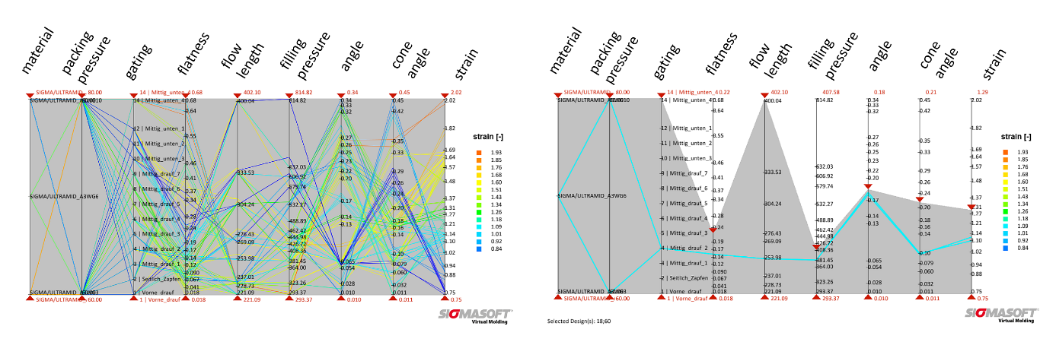
Figure 2 – The left side shows all calculated designs which are each represented by a colored line. The vertical sliders represent the variables and objectives. With the help of these sliders the different parameters are limited further and thus the ideal design is selected (right).

SIGMA (www.sigmasoft.de) is sister company to MAGMA (www.magmasoft.de), the world market leader in casting process simulation technology based in Aachen, Germany. Our SIGMASOFT® Virtual Molding technology optimizes the manufacturing process for injection molded plastic components. SIGMASOFT® Virtual Molding combines the 3D geometry of the parts and runners with the complete mold assembly and temperature control system and incorporates the actual production process to develop a turnkey injection mold with an optimized process.

At SIGMA and MAGMA, our goal is to help our customers achieve required part quality during the first trial. The two product lines – injection molded polymers and metal castings – share the same 3D simulation technologies focused on the simultaneous optimization of design and process. SIGMASOFT® Virtual Molding thus includes a variety of process-specific models and 3D simulation methods developed, validated and constantly improved for over 25 years. A process-driven simulation tool, SIGMASOFT® Virtual Molding provides a tremendous benefit to production facilities. Imagine your business when every mold you build produces required quality the first time, every time. That is our goal. This technology cannot be compared to any other simulation approach employed in plastics injection molding.

New product success requires a different communication between designs, materials, and processes that design simulation is not meant for. SIGMASOFT® Virtual Molding provides this communication. SIGMA support engineers, with 450 years of combined technical education and practical experience, can support your engineering goals with applications specific solutions. SIGMA offers direct sales, engineering, training, implementation, and support, by plastics engineers worldwide.

This press information is available to download as pdf and doc format under the following link: https://www.sigmasoft.de/en/press/

