Contact:
B.Sc. Vanessa Frekers
v.frekers@sigmasoft.de
+49-241-89495-0
Kackertstr. 11
D-52072 – Aachen

Press Release
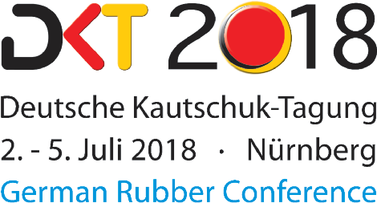

Hall 12, Stand 419

Elastomer Parts
Finding the Optimal Runner System via Virtual DoE

Ensuring part quality while minimizing scrap

Increasingly complex plastic parts, which need to meet economical as well as ecological standards, pose an enormous challenge for injection molders. Tools like the virtual DoE, featured by the SIGMASOFT® Virtual Molding Technology, help rising to these challenges, e.g. by finding the optimal mold design for runner systems. This can help to increase the part quality by a substantial amount while reducing scrap in early stages of the development phase.

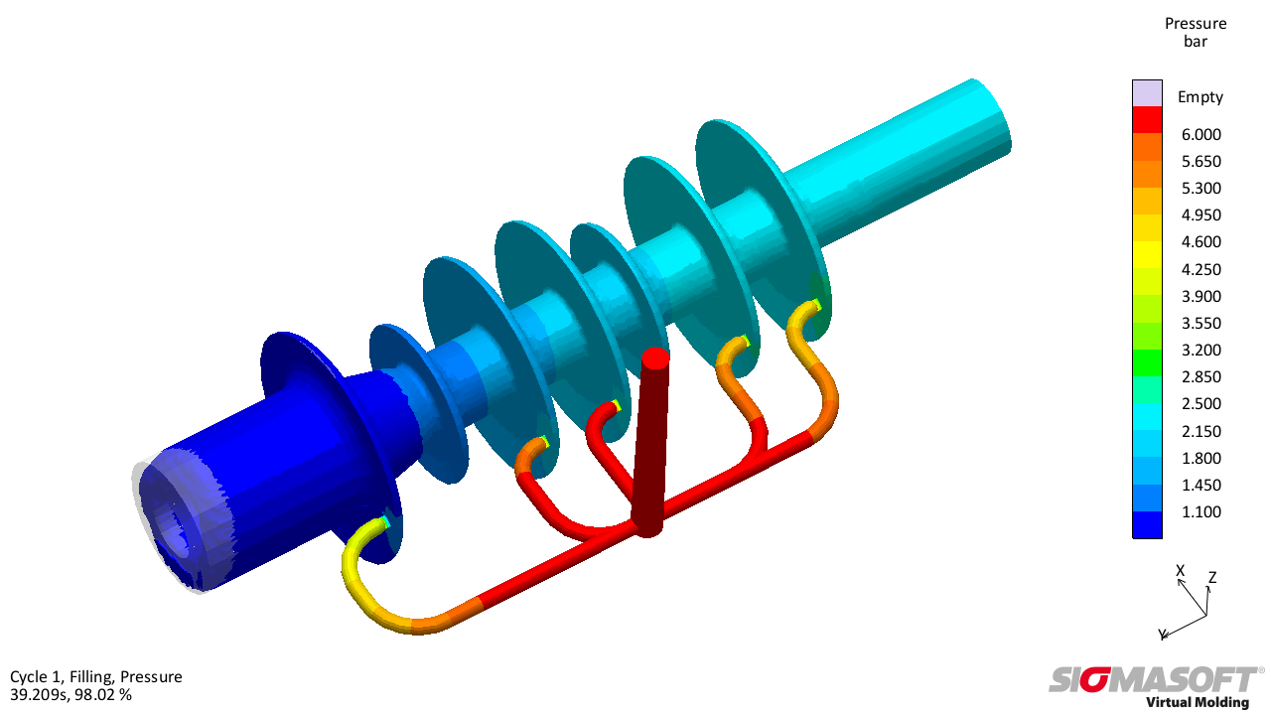
Figure 1 – Distribution of pressure while filling in the original design, the runner system causes a distinct unbalanced filling
Finding the Optimal Runner System via Virtual DoE

Aachen, July 2nd, 2018 – The increasing complexity of elastomer parts poses a couple of new challenges for injection molders. Because of economical and ecological aspects, cycle times and scrap output should be as low as possible. The new simulation approaches, featured in SIGMASOFT® Virtual Molding, enable the injection molders to design their parts, molds and processes in the early development phase, thus finding the optimal concept to meet all requirements by balancing part and mold design as well as process configuration.
The example at hand illustrates one of these newly arousing problems. At the beginning of the development phase the questions for the ideal part filling and a suitable concept for connection and sprue came up. At the same time the part should be filled with as little pressure as possible. A first part and sprue design allowed the low pressure demand (Figure 1, left), however, the filling behavior showed significant imbalance.
The first measures taken into consideration were a changed number of gates, altered gate thicknesses and different hot runner positions in relation to the gates. Instead of testing the numerous possible combinations of these measures using trial-and-error on the computer manually, a virtual DoE (Design of Experiments) was conducted. Based on filling time difference and pressure demand of the part’s ends, every possible combination was evaluated simultaneously.
First checking the variations of quantity and thickness of the gates does not lead to the desired success, since there is no clear correlation between these two variables, the pressure demand and balanced filling in evidence. Changing the position of the sprue in relation to the gates leads to a distinct alteration of pressure demand and filling time difference at the part’s ends. Because both correlations act contrary to each other, the two assessment criteria need to be weighed out against each other in order to determine the best design possible.
In the example at hand, the balanced filling of the part was rated higher, leading to a final design which focuses on this aspect despite having a slightly higher pressure demand (Figure 2).
Therefore, SIGMASOFT® Virtual Molding was able to find the best compromise between different criteria, leading to the optimal design possible under the given circumstances. The virtual mold design in an early development stage eliminated the need for mold changes, thus increasing the part quality substantially.
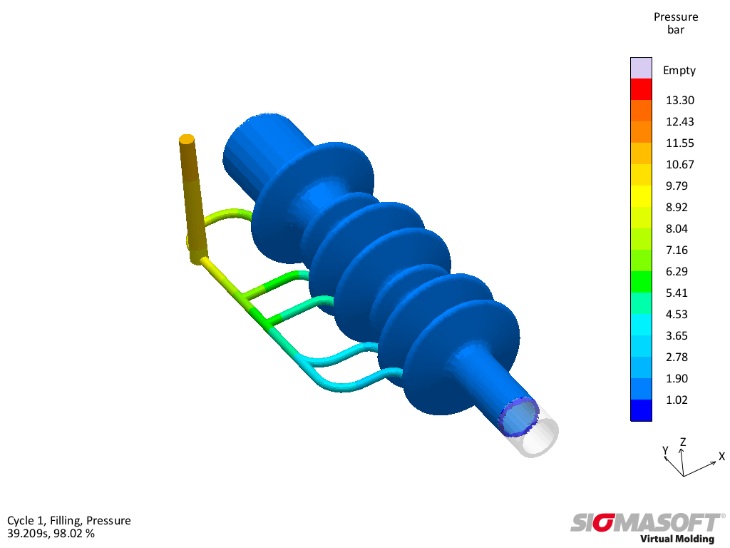
Figure 2 – Pressure distribution in the virtually optimized version; the slightly increased pressure demand leads to a more balanced filling behavior

SIGMA (www.sigmasoft.de) is sister company to MAGMA (www.magmasoft.de), the world market leader in casting process simulation technology based in Aachen, Germany. Our SIGMASOFT® Virtual Molding technology optimizes the manufacturing process for injection molded plastic components. SIGMASOFT® Virtual Molding combines the 3D geometry of the parts and runners with the complete mold assembly and temperature control system and incorporates the actual production process to develop a turnkey injection mold with an optimized process.

At SIGMA and MAGMA, our goal is to help our customers achieve required part quality during the first trial. The two product lines – injection molded polymers and metal castings – share the same 3D simulation technologies focused on the simultaneous optimization of design and process. SIGMASOFT® Virtual Molding thus includes a variety of process-specific models and 3D simulation methods developed, validated and constantly improved for over 25 years. A process-driven simulation tool, SIGMASOFT® Virtual Molding provides a tremendous benefit to production facilities. Imagine your business when every mold you build produces required quality the first time, every time. That is our goal. This technology cannot be compared to any other simulation approach employed in plastics injection molding.

New product success requires a different communication between designs, materials, and processes that design simulation is not meant for. SIGMASOFT® Virtual Molding provides this communication. SIGMA support engineers, with 450 years of combined technical education and practical experience, can support your engineering goals with applications specific solutions. SIGMA offers direct sales, engineering, training, implementation, and support, by plastics engineers worldwide.

This press information is available to download as pdf and doc format under the following link: www.sigmasoft.de/press

