Contact:
B.Sc. Vanessa Frekers
v.frekers@sigmasoft.de
+49-241-89495-0
Kackertstr. 11
D-52072 – Aachen

Press Release

LSR Injection Molding
Cost-effective production of LSR applications with
SIGMASOFT® Virtual Molding

At the Fakuma 2017 two LSR applications will demonstrate how SIGMASOFT® Virtual Molding is used to optimize the tempering concepts and processing windows in LSR molding. SIGMASOFT® Virtual Molding identifies early risks in the mold concept and process definition, and makes it possible to try different solutions quickly and cost-efficiently.

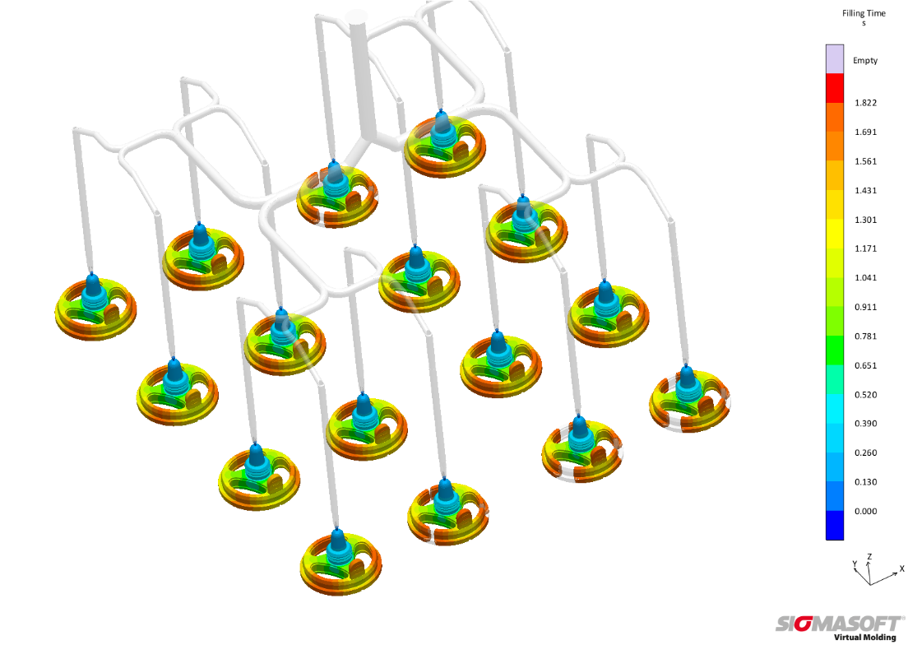
Figure 1 – With SIGMASOFT® Virtual Molding it is possible to accurately reproduce the flow and curing behavior in LSR molding. A balanced cavity filling delivers consistent part quality and reduces pressure demand.
Cost-effective production of LSR applications with
SIGMASOFT® Virtual Molding
Aachen, October 17th 2017 – LSRs (liquid silicon rubbers) are used more and more frequently in daily life. However, compared with other silicons, these materials are challenging, due to a narrow processing window and to the impossibility to recycle waste. This makes it all the more important to guarantee an efficient mold and process design, with the least possible waste, where the required part quality and functionality are achieved.
SIGMASOFT® Virtual Molding has established itself over the past years as a unique tool to design LSR molds and to find the optimum processing window in LSR processing. Working as a virtual injection molding machine, it is able to accurately predict the flow and curing behavior of LSR applications and the performance of LSR molds. Typical defects such as unbalanced filling or curing in multi-cavity molds, incomplete filling or curing, diesel effects or weld lines can be predicted and corrected. It is also possible to optimize cycle times through thermal design or adjustments of the processing window. SIGMASOFT® Virtual Molding identifies early risks in the mold concept and process definition, and makes it possible to try different solutions quickly and cost-efficiently.
SIGMA Engineering (Aachen) demonstrates the benefits of its SIGMASOFT® Virtual Molding approach in the molding of LSR applications at Fakuma 2017. In a project together with the partners Elmet Elastomere Produktions- und Dienstleistungs-GmbH, Dow Corning GmbH and ENGEL Austria GmbH, a degasification valve for drink bottles will be produced in LSR. The 16-cavity cold-runner mold is provided by Elmet, and with the help of SIGMASOFT® Virtual Molding the thermal layout of the mold was evaluated to achieve a complete filling and a symmetric curing behavior in all cavities. The complex geometrical structure of the part with varying cross section was one of the aspects challenging an even curing reaction, which was another focus of the analysis. The part is produced live during Fakuma at the booth of ENGEL (Hall A5, 5204).
Another LSR application of the SIGMASOFT® Virtual Molding technology is presented in hall B3 at booth 3211 in cooperation with Nexus Automation GmbH. Here a 16-cavity mold will produce puzzle parts in an innovative mold concept. In this application the uniform curing of all cavities is crucial and can only be achieved with a stable thermal mold layout and elaborate molding process.

SIGMA (www.sigmasoft.de) is sister company to MAGMA (www.magmasoft.de), the world market leader in casting process simulation technology based in Aachen, Germany. Our SIGMASOFT® Virtual Molding technology optimizes the manufacturing process for injection molded plastic components. SIGMASOFT® Virtual Molding combines the 3D geometry of the parts and runners with the complete mold assembly and temperature control system and incorporates the actual production process to develop a turnkey injection mold with an optimized process.

At SIGMA and MAGMA, our goal is to help our customers achieve required part quality during the first trial. The two product lines – injection molded polymers and metal castings – share the same 3D simulation technologies focused on the simultaneous optimization of design and process. SIGMASOFT® Virtual Molding thus includes a variety of process-specific models and 3D simulation methods developed, validated and constantly improved for over 25 years. A process-driven simulation tool, SIGMASOFT® Virtual Molding provides a tremendous benefit to production facilities. Imagine your business when every mold you build produces required quality the first time, every time. That is our goal. This technology cannot be compared to any other simulation approach employed in plastics injection molding.

New product success requires a different communication between designs, materials, and processes that design simulation is not meant for. SIGMASOFT® Virtual Molding provides this communication. SIGMA support engineers, with 450 years of combined technical education and practical experience, can support your engineering goals with applications specific solutions. SIGMA offers direct sales, engineering, training, implementation, and support, by plastics engineers worldwide.

This press information is available to download as pdf and doc format under the following link: www.sigmasoft.de/press

