Contact:
B.Sc. Vanessa Frekers
v.frekers@sigmasoft.de
+49-241-89495-0
Kackertstr. 11
D-52072 – Aachen

Press Release

Mold Design
Autonomous Optimization Reduces Costs in Injection Molding

An example demonstrates the application of the Autonomous Optimization tool available in SIGMASOFT® Virtual Molding. The mold for a thick-walled part had to deliver a cycle time below 60 seconds, which could be realized with different tempering concepts. The best cooling configuration was found at the lower manufacturing cost.
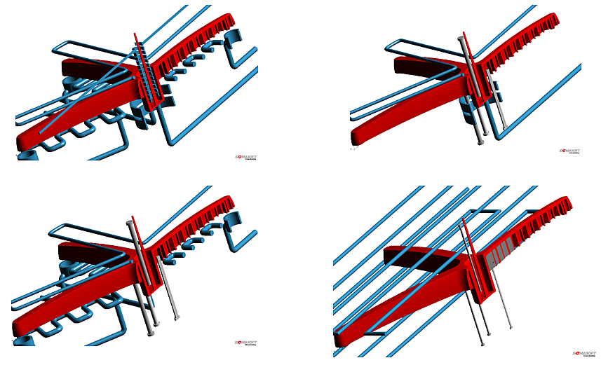
Figure 1 – The part (in red) had to be produced with a cycle time below 60 seconds. The Autonomous Optimization tool found out which cooling configuration delivered the desired cycle time at the lowest cost.
Autonomous Optimization Reduces Costs in Injection Molding

Aachen, October 17th 2017 – Tempering problems account for around 60% of the total of quality issues in injection molded parts. With an ever increasing pressure on individual part costs and shorter mold development deadlines it is imperative to produce affordable, reliable and efficient mold solutions within the shortest possible time.
A new tool, released at Fakuma 2017 for the first time, allows mold makers to virtually identify the most efficient solution in their designs. SIGMA Engineering GmbH (Aachen, Germany) has released the Autonomous Optimization solution as part of its SIGMASOFT® Virtual Molding software. It helps the user to find the best possible solution out of all the possible combinations of a parameter set.
A base for an office roll chair had to be produced. The mold maker was confronted with the problem of designing the most efficient mold possible at the lowest cost. A cycle time below 60 seconds was targeted.
The mold maker selected the different parameters which he could vary in the mold to achieve the requested cycle time. The mold material, the layout and diameter of the tempering channels, a conformal cooling concept and high-conductivity pins were selected as the variables. All the possible combinations of these variables gave a total of 40,000 different mold configurations. The autonomous simulation tool worked to find amongst these possible scenarios the ones that released a cycle time below 60 seconds.
Amongst the different possible design combinations delivering the target cycle time it was then possible to filter the ones with lower cost. For this particular application, it was found that conformal cooling was not necessary, and that the required heat dissipation effect to achieve the targeted cycle time could be obtained using high-conductivity pins with 4 mm and 10 mm in diameter. The required diameter in the water channels was found to be 6 mm.
The Autonomous Optimization available in SIGMASOFT® Virtual Molding is able to find the most effective mold design at the lowest possible cost. Not only cycle time can be optimized, but also part deformation, energy costs and molding defects can be minimized through the identification of the optimum parameter combination.

SIGMA (www.sigmasoft.de) is sister company to MAGMA (www.magmasoft.de), the world market leader in casting process simulation technology based in Aachen, Germany. Our SIGMASOFT® Virtual Molding technology optimizes the manufacturing process for injection molded plastic components. SIGMASOFT® Virtual Molding combines the 3D geometry of the parts and runners with the complete mold assembly and temperature control system and incorporates the actual production process to develop a turnkey injection mold with an optimized process.

At SIGMA and MAGMA, our goal is to help our customers achieve required part quality during the first trial. The two product lines – injection molded polymers and metal castings – share the same 3D simulation technologies focused on the simultaneous optimization of design and process. SIGMASOFT® Virtual Molding thus includes a variety of process-specific models and 3D simulation methods developed, validated and constantly improved for over 25 years. A process-driven simulation tool, SIGMASOFT® Virtual Molding provides a tremendous benefit to production facilities. Imagine your business when every mold you build produces required quality the first time, every time. That is our goal. This technology cannot be compared to any other simulation approach employed in plastics injection molding.

New product success requires a different communication between designs, materials, and processes that design simulation is not meant for. SIGMASOFT® Virtual Molding provides this communication. SIGMA support engineers, with 450 years of combined technical education and practical experience, can support your engineering goals with applications specific solutions. SIGMA offers direct sales, engineering, training, implementation, and support, by plastics engineers worldwide.

This press information is available to download as pdf and doc format under the following link: www.sigmasoft.de/press

